Part 1

1. Binding to a dropdown list control-

//guiDDList.aspx code

<%@ Page Title="" Language="C#" MasterPageFile="~/Homework.Master" AutoEventWireup="true" CodeBehind="guiDDList.aspx.cs" Inherits="Project.Pages.guiDDList" %>

<asp:Content ID="Content1" ContentPlaceHolderID="HeadSection" runat="server">

</asp:Content>

<asp:Content ID="Content2" ContentPlaceHolderID="ContentSection" runat="server">

<p>

<br />

</p>

<p>

<asp:SqlDataSource ID="SqlDataSource1" runat="server"

ConnectionString="<%$ ConnectionStrings:MyCS %>"

SelectCommand="SELECT [authorid], [lastname] FROM [Authors] ORDER BY

[lastname]"></asp:SqlDataSource>

</p>

<p>

<asp:DropDownList ID="DropDownList1" runat="server" AutoPostBack="True" DataSourceID="SqlDataSource1" DataTextField="lastname" DataValueField="authorid">

</asp:DropDownList>

</p>

<asp:Label ID="Label1" runat="server" Text="Please select an author."></asp:Label>

<p>

</p>

<p>

</p>

<p>

</p>

<p>

</p>

<p>

</p>

<p>

</p>

<p>

</p>

</asp:Content>

//guiDDList.aspx.cs code

namespace Project.Pages

{

public partial class guiDDList : System.Web.UI.Page

{

protected void Page_Load(object sender, EventArgs e)

{

if(Page.IsPostBack)

{

Label1.Text = DropDownList1.SelectedItem.Value + "-" +

DropDownList1.SelectedItem.Text;

}

}

}

}

//guiDDList.aspx in browser

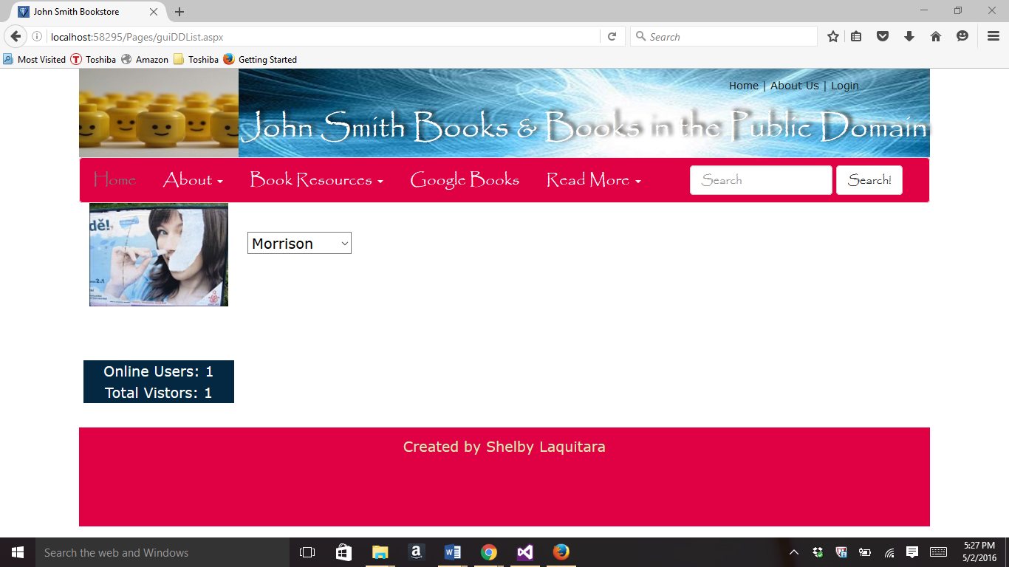

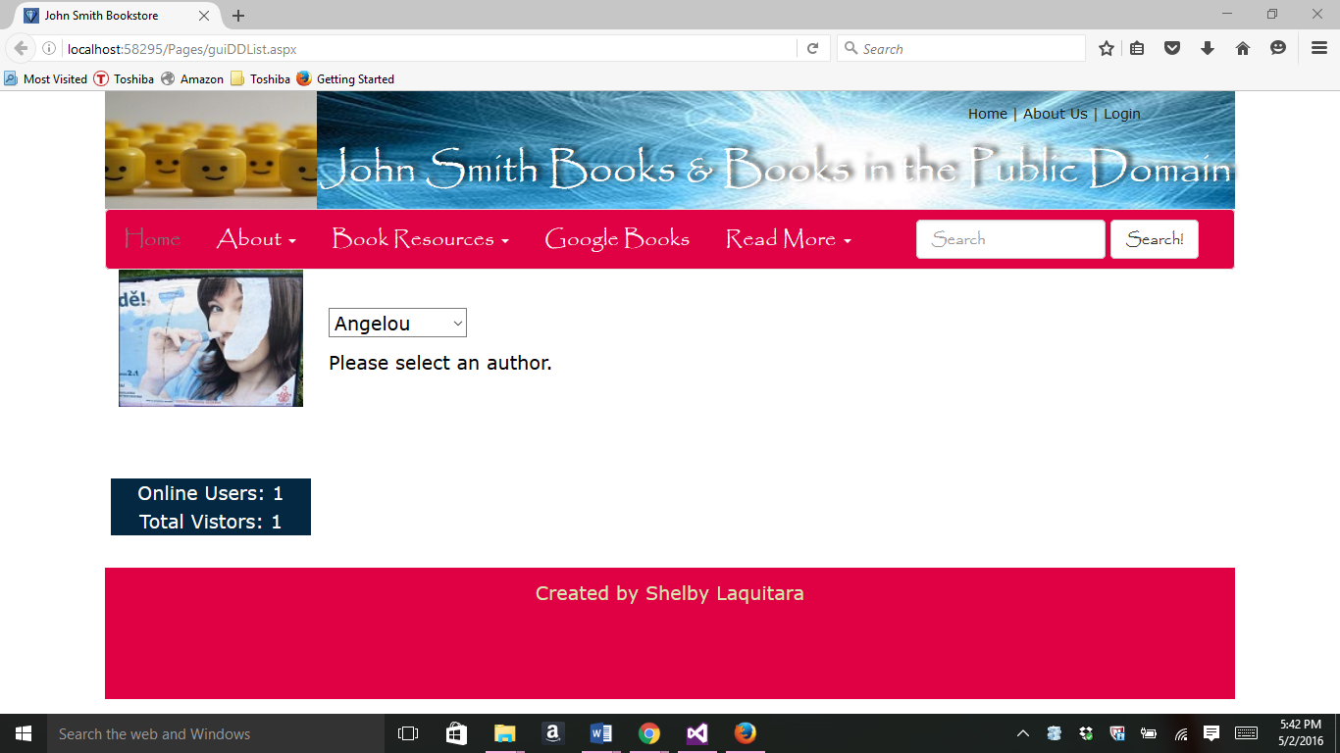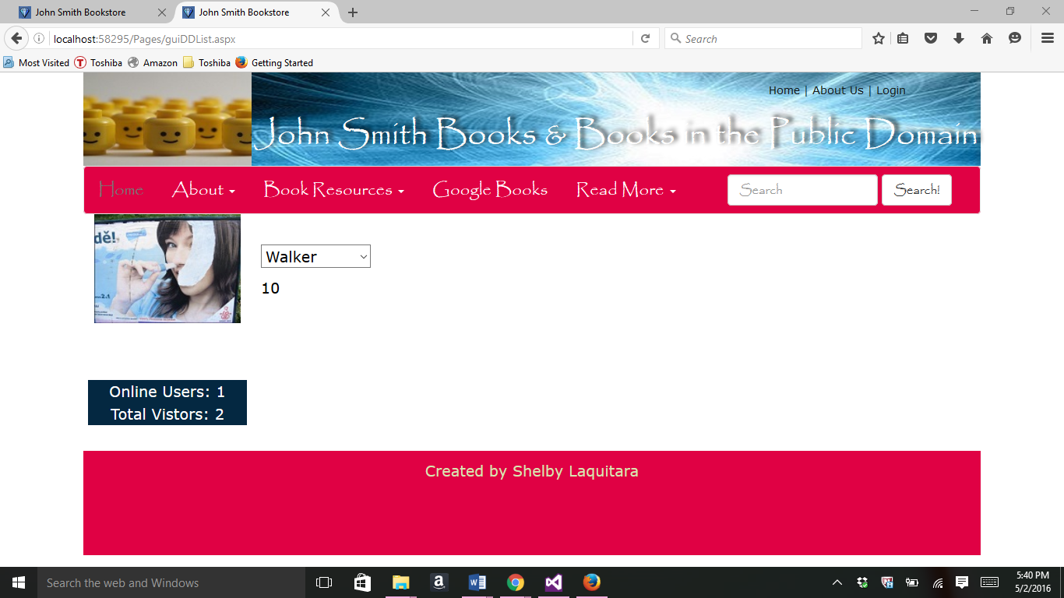

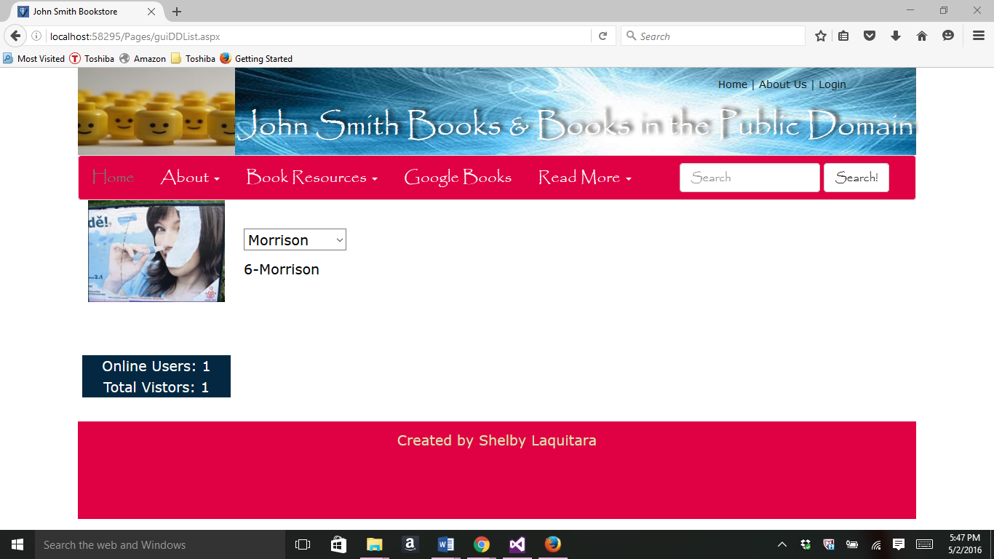

1. Binding to a data list control-

//guiDataList.aspx code

<%@ Page Title="" Language="C#" MasterPageFile="~/Homework.Master" AutoEventWireup="true" CodeBehind="guiDataList.aspx.cs" Inherits="Project.Pages.guiDataList" %>

<asp:Content ID="Content1" ContentPlaceHolderID="HeadSection" runat="server">

</asp:Content>

<asp:Content ID="Content2" ContentPlaceHolderID="ContentSection" runat="server">

<p>

<br />

</p>

<p>

<asp:SqlDataSource ID="SqlDataSource1" runat="server"

ConnectionString="<%$ ConnectionStrings:MyCS %>"

SelectCommand="SELECT * FROM [Books] ORDER BY [booktitle]"></asp:SqlDataSource>

</p>

<p>

<asp:Label ID="Label1" runat="server" Text="Data List"></asp:Label>

</p>

<p>

<asp:DataList ID="DataList1" runat="server" DataKeyField="bookid"

DataSourceID="SqlDataSource1" BackColor="LightGoldenrodYellow"

BorderColor="Tan" BorderWidth="1px" CellPadding="4" ForeColor="Black"

RepeatColumns="2">

<AlternatingItemStyle BackColor="PaleGoldenrod" />

<FooterStyle BackColor="Tan" />

<HeaderStyle BackColor="Tan" Font-Bold="True" />

<ItemTemplate>

Book ID:

<asp:Label ID="bookidLabel" runat="server" Text='<%# Eval("bookid") %>' />

<br />

Book Title:

<asp:Label ID="booktitleLabel" runat="server" Text='<%# Eval("booktitle") %>' />

<br />

Book Description:

<asp:Label ID="bookdescriptionLabel" runat="server" Text='<%# Eval("bookdescription") %>' />

<br />

Price:

<asp:Label ID="priceLabel" runat="server" Text='<%# Eval("price") %>' />

<br />

Publication Date:

<asp:Label ID="pubdateLabel" runat="server" Text='<%# Eval("pubdate") %>' />

<br />

Picture:

<asp:Label ID="pictureLabel" runat="server" Text='<%# Eval("picture") %>' />

<br />

Category ID:

<asp:Label ID="catidLabel" runat="server" Text='<%# Eval("catid") %>' />

<br />

Author ID:

<asp:Label ID="authoridLabel" runat="server" Text='<%# Eval("authorid") %>' />

<br />

<br />

</ItemTemplate>

<SelectedItemStyle BackColor="DarkSlateBlue" ForeColor="GhostWhite" />

</asp:DataList>

</p>

<p>

</p>

<p>

</p>

<p>

</p>

</asp:Content>

//guiDataList.aspx in browser

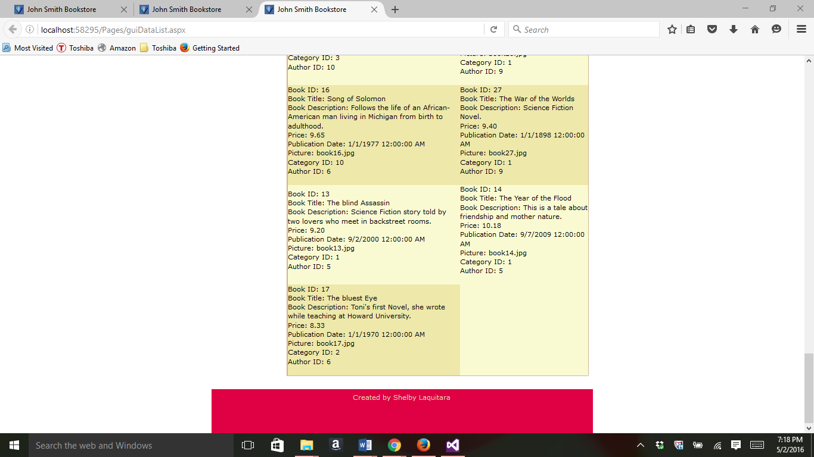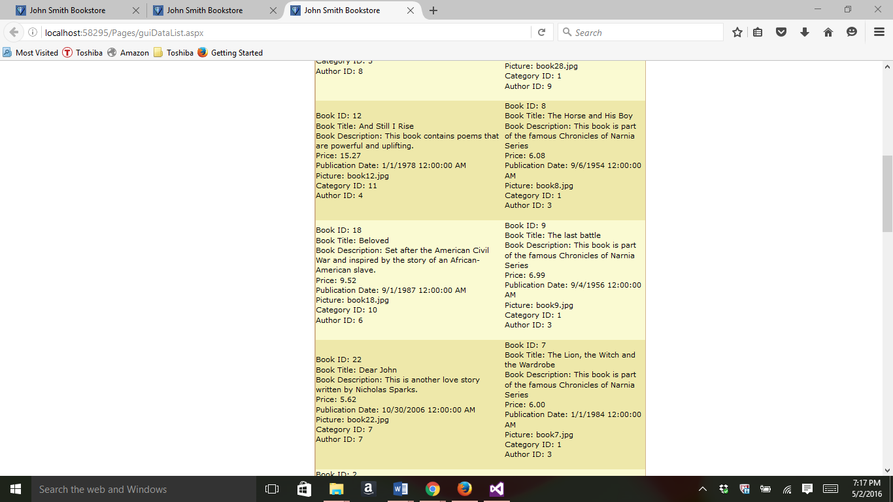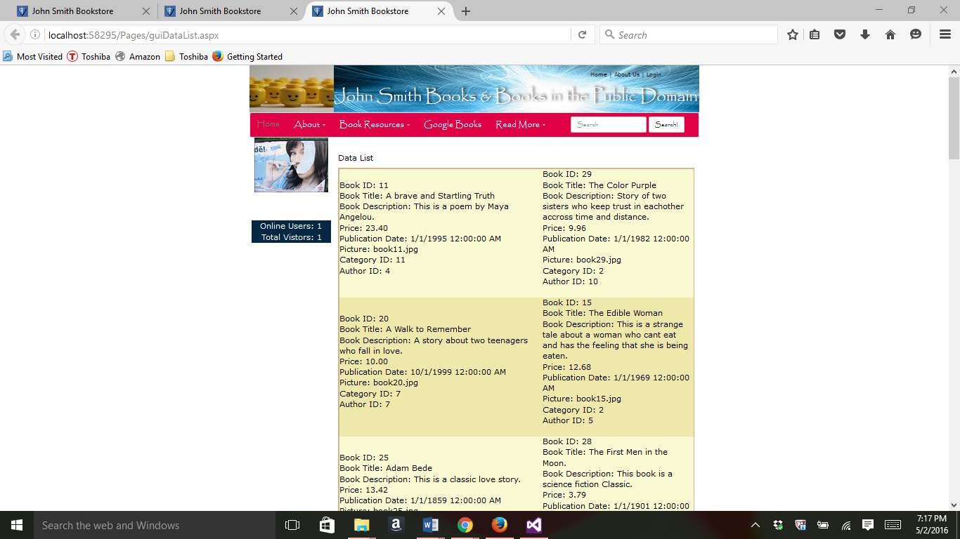

1. Binding to a gridview control

//guiGridView.apsx

<%@ Page Title="" Language="C#" MasterPageFile="~/Homework.Master" AutoEventWireup="true" CodeBehind="guiGridView.aspx.cs" Inherits="Project.Pages.guiGridView" %>

<asp:Content ID="Content1" ContentPlaceHolderID="HeadSection" runat="server">

</asp:Content>

<asp:Content ID="Content2" ContentPlaceHolderID="ContentSection" runat="server">

<p>

<br />

<asp:SqlDataSource ID="SqlDataSource1" runat="server"

ConnectionString="<%$ ConnectionStrings:MyCS %>"

SelectCommand="SELECT [lastname], [authorid] FROM [Authors] ORDER BY [lastname]">

</asp:SqlDataSource>

</p>

<p>

<asp:DropDownList ID="DropDownList1" runat="server"

AutoPostBack="True" DataSourceID="SqlDataSource1"

DataTextField="lastname" DataValueField="authorid">

</asp:DropDownList>

</p>

<p>

&nbsp;</p>

<p>

<asp:SqlDataSource ID="SqlDataSource2" runat="server"

ConnectionString="<%$ ConnectionStrings:MyCS %>"

SelectCommand="SELECT * FROM [Books] WHERE ([authorid] = @authorid) ORDER BY [booktitle]" DeleteCommand="DELETE FROM [Books] WHERE [bookid] = @bookid" InsertCommand="INSERT INTO [Books] ([bookid], [booktitle], [bookdescription], [price], [pubdate], [picture], [catid], [authorid]) VALUES (@bookid, @booktitle, @bookdescription, @price, @pubdate, @picture, @catid, @authorid)" UpdateCommand="UPDATE [Books] SET [booktitle] = @booktitle, [bookdescription] = @bookdescription, [price] = @price, [pubdate] = @pubdate, [picture] = @picture, [catid] = @catid, [authorid] = @authorid WHERE [bookid] = @bookid">

<DeleteParameters>

<asp:Parameter Name="bookid" Type="Int32" />

</DeleteParameters>

<InsertParameters>

<asp:Parameter Name="bookid" Type="Int32" />

<asp:Parameter Name="booktitle" Type="String" />

<asp:Parameter Name="bookdescription" Type="String" />

<asp:Parameter Name="price" Type="Decimal" />

<asp:Parameter Name="pubdate" Type="DateTime" />

<asp:Parameter Name="picture" Type="String" />

<asp:Parameter Name="catid" Type="Int32" />

<asp:Parameter Name="authorid" Type="Int32" />

</InsertParameters>

<SelectParameters>

<asp:ControlParameter ControlID="DropDownList1"

Name="authorid" PropertyName="SelectedValue" Type="Int32" />

</SelectParameters>

<UpdateParameters>

<asp:Parameter Name="booktitle" Type="String" />

<asp:Parameter Name="bookdescription" Type="String" />

<asp:Parameter Name="price" Type="Decimal" />

<asp:Parameter Name="pubdate" Type="DateTime" />

<asp:Parameter Name="picture" Type="String" />

<asp:Parameter Name="catid" Type="Int32" />

<asp:Parameter Name="authorid" Type="Int32" />

<asp:Parameter Name="bookid" Type="Int32" />

</UpdateParameters>

</asp:SqlDataSource>

</p>

<p>

<asp:GridView ID="GridView1" runat="server" AllowPaging="True"

AllowSorting="True" AutoGenerateColumns="False"

BackColor="LightGoldenrodYellow" BorderColor="Tan"

BorderWidth="1px" CellPadding="4" DataKeyNames="bookid"

DataSourceID="SqlDataSource2" ForeColor="Black" GridLines="None" Width="745px">

<AlternatingRowStyle BackColor="PaleGoldenrod" />

<Columns>

<asp:CommandField ButtonType="Button" ShowDeleteButton="True" ShowEditButton="True" />

<asp:BoundField DataField="bookid" HeaderText="ID" ReadOnly="True"

SortExpression="bookid" >

<HeaderStyle HorizontalAlign="Center" />

<ItemStyle HorizontalAlign="Center" />

</asp:BoundField>

<asp:BoundField DataField="booktitle" HeaderText="Book Title"

SortExpression="booktitle" >

<HeaderStyle HorizontalAlign="Center" />

</asp:BoundField>

<%--<asp:BoundField DataField="bookdescription" HeaderText="bookdescription"

SortExpression="bookdescription" />--%>

<asp:BoundField DataField="price" HeaderText="Price"

SortExpression="price" DataFormatString="{0:c}" >

<HeaderStyle HorizontalAlign="Center" />

<ItemStyle HorizontalAlign="Center" />

</asp:BoundField>

<asp:BoundField DataField="pubdate" HeaderText="Publish Date"

SortExpression="pubdate" DataFormatString="{0:d}">

<HeaderStyle HorizontalAlign="Center" />

<ItemStyle HorizontalAlign="Center" />

</asp:BoundField>

<asp:BoundField DataField="picture" HeaderText="Picture"

SortExpression="picture" >

<HeaderStyle HorizontalAlign="Center" />

<ItemStyle HorizontalAlign="Center" />

</asp:BoundField>

<%--<asp:BoundField DataField="catid" HeaderText="catid"

SortExpression="catid" />

<asp:BoundField DataField="authorid" HeaderText="authorid"

SortExpression="authorid" />--%>

</Columns>

<FooterStyle BackColor="Tan" />

<HeaderStyle BackColor="Tan" Font-Bold="True" />

<PagerSettings Mode="NextPrevious" />

<PagerStyle BackColor="PaleGoldenrod" ForeColor="DarkSlateBlue"

HorizontalAlign="Center" />

<SelectedRowStyle BackColor="DarkSlateBlue" ForeColor="GhostWhite" />

<SortedAscendingCellStyle BackColor="#FAFAE7" />

<SortedAscendingHeaderStyle BackColor="#DAC09E" />

<SortedDescendingCellStyle BackColor="#E1DB9C" />

<SortedDescendingHeaderStyle BackColor="#C2A47B" />

</asp:GridView>

</p>

<p>

</p>

<p>

</p>

<p>

</p>

</asp:Content>

//guiGridView.apsx in browser

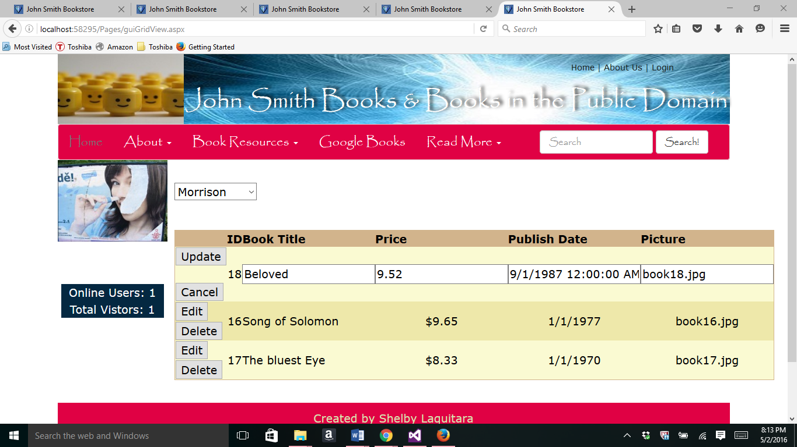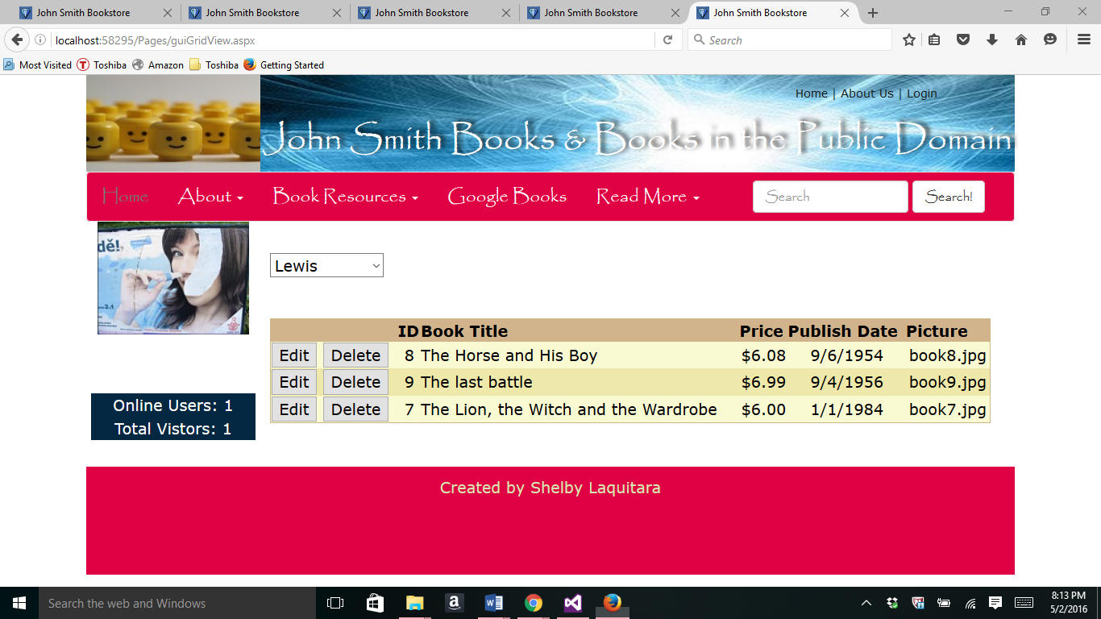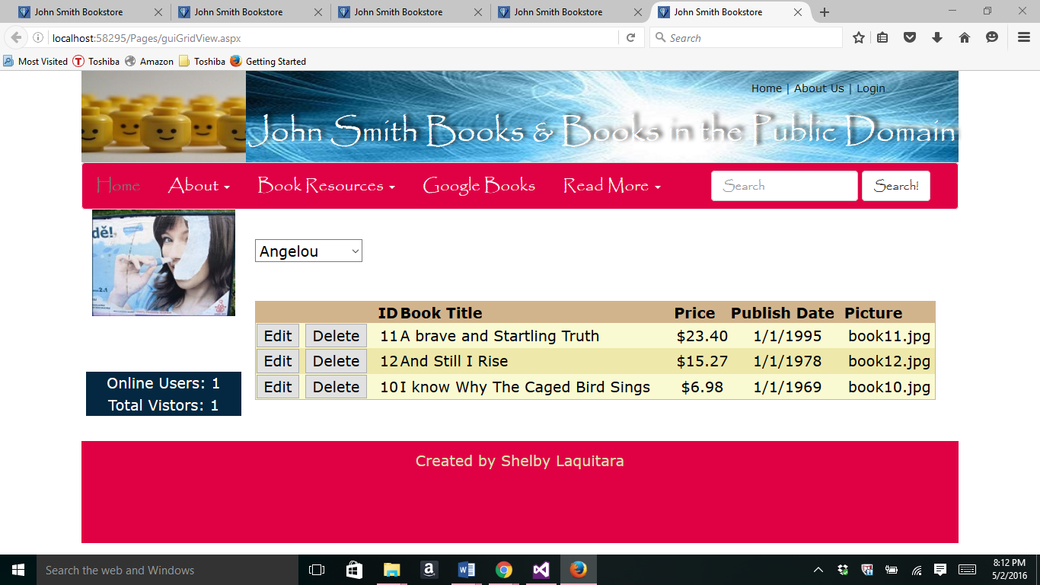

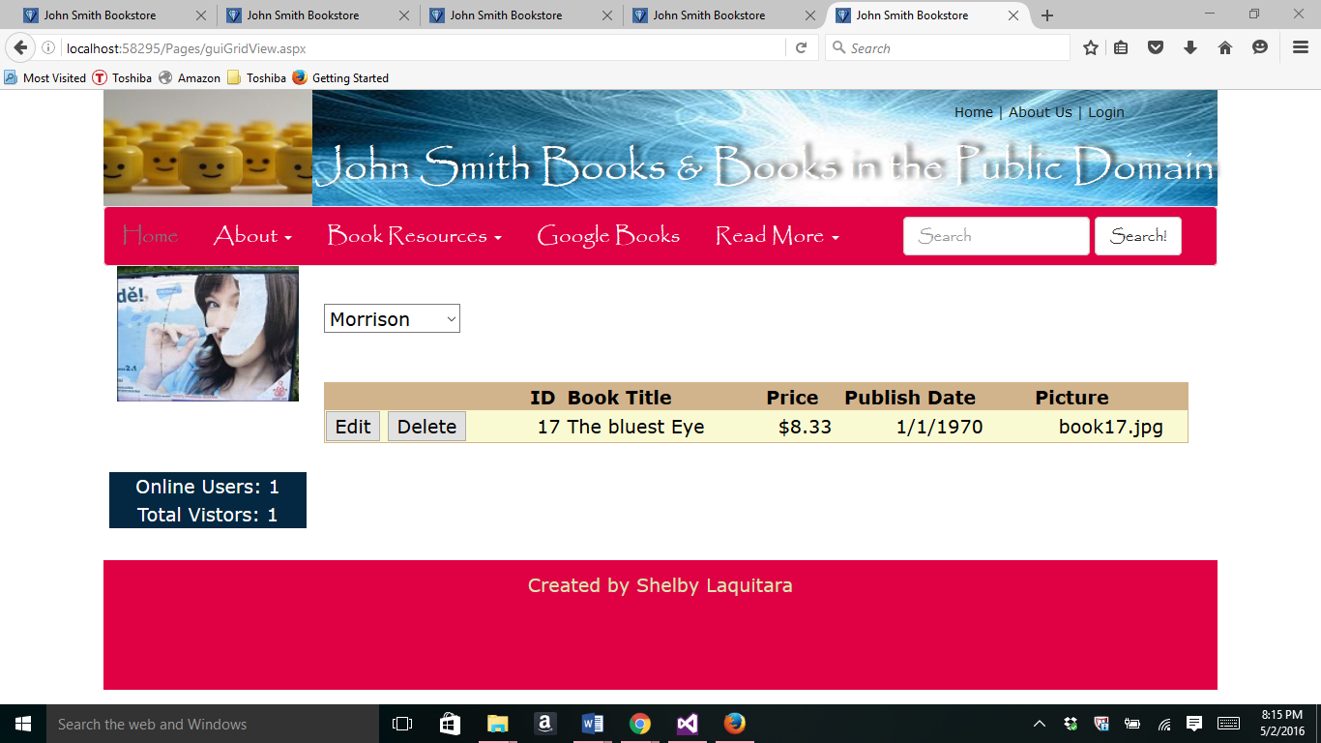

1. Binding to a Details View Control

//guiDetailsView.aspx code

<%@ Page Title="" Language="C#" MasterPageFile="~/Homework.Master" AutoEventWireup="true" CodeBehind="guiDetailsView.aspx.cs" Inherits="Project.Pages.guiDetailsView" %>

<asp:Content ID="Content1" ContentPlaceHolderID="HeadSection" runat="server">

</asp:Content>

<asp:Content ID="Content2" ContentPlaceHolderID="ContentSection" runat="server">

<p>

<br />

<asp:SqlDataSource ID="SqlDataSource1" runat="server" ConnectionString="<%$ ConnectionStrings:MyCS %>" DeleteCommand="DELETE FROM [Books] WHERE [bookid] = @bookid" InsertCommand="INSERT INTO [Books] ([bookid], [booktitle], [bookdescription], [price], [pubdate], [picture], [catid], [authorid]) VALUES (@bookid, @booktitle, @bookdescription, @price, @pubdate, @picture, @catid, @authorid)" SelectCommand="SELECT * FROM [Books]" UpdateCommand="UPDATE [Books] SET [booktitle] = @booktitle, [bookdescription] = @bookdescription, [price] = @price, [pubdate] = @pubdate, [picture] = @picture, [catid] = @catid, [authorid] = @authorid WHERE [bookid] = @bookid">

<DeleteParameters>

<asp:Parameter Name="bookid" Type="Int32" />

</DeleteParameters>

<InsertParameters>

<asp:Parameter Name="bookid" Type="Int32" />

<asp:Parameter Name="booktitle" Type="String" />

<asp:Parameter Name="bookdescription" Type="String" />

<asp:Parameter Name="price" Type="Decimal" />

<asp:Parameter Name="pubdate" Type="DateTime" />

<asp:Parameter Name="picture" Type="String" />

<asp:Parameter Name="catid" Type="Int32" />

<asp:Parameter Name="authorid" Type="Int32" />

</InsertParameters>

<UpdateParameters>

<asp:Parameter Name="booktitle" Type="String" />

<asp:Parameter Name="bookdescription" Type="String" />

<asp:Parameter Name="price" Type="Decimal" />

<asp:Parameter Name="pubdate" Type="DateTime" />

<asp:Parameter Name="picture" Type="String" />

<asp:Parameter Name="catid" Type="Int32" />

<asp:Parameter Name="authorid" Type="Int32" />

<asp:Parameter Name="bookid" Type="Int32" />

</UpdateParameters>

</asp:SqlDataSource>

</p>

<p>

<asp:DetailsView ID="DetailsView1" runat="server" AllowPaging="True" AutoGenerateRows="False" BackColor="LightGoldenrodYellow" BorderColor="Tan" BorderWidth="1px" CellPadding="2" DataKeyNames="bookid" DataSourceID="SqlDataSource1" ForeColor="Black" GridLines="None" Height="83px" Width="570px">

<AlternatingRowStyle BackColor="PaleGoldenrod" />

<EditRowStyle BackColor="DarkSlateBlue" ForeColor="GhostWhite" />

<Fields>

<asp:BoundField DataField="bookid" HeaderText="Book ID:" ReadOnly="True" SortExpression="bookid" />

<asp:BoundField DataField="booktitle" HeaderText="Book Title:" SortExpression="booktitle" />

<asp:BoundField DataField="bookdescription" HeaderText="Description:" SortExpression="bookdescription" />

<asp:BoundField DataField="price" DataFormatString="{0:c}" HeaderText="Price:" SortExpression="price" />

<asp:BoundField DataField="pubdate" HeaderText="Publish Date:" SortExpression="pubdate" />

<asp:BoundField DataField="picture" HeaderText="Picture:" SortExpression="picture" />

<asp:BoundField DataField="catid" HeaderText="Category ID:" SortExpression="catid" />

<asp:BoundField DataField="authorid" HeaderText="Author ID:" SortExpression="authorid" />

<asp:CommandField ShowDeleteButton="True" ShowEditButton="True" ShowInsertButton="True" />

</Fields>

<FooterStyle BackColor="Tan" />

<HeaderStyle BackColor="Tan" Font-Bold="True" />

<PagerStyle BackColor="PaleGoldenrod" ForeColor="DarkSlateBlue" HorizontalAlign="Center" />

</asp:DetailsView>

</p>

<p>

</p>

<p>

</p>

<p>

</p>

</asp:Content>

//guiDetailsView.aspx in browser

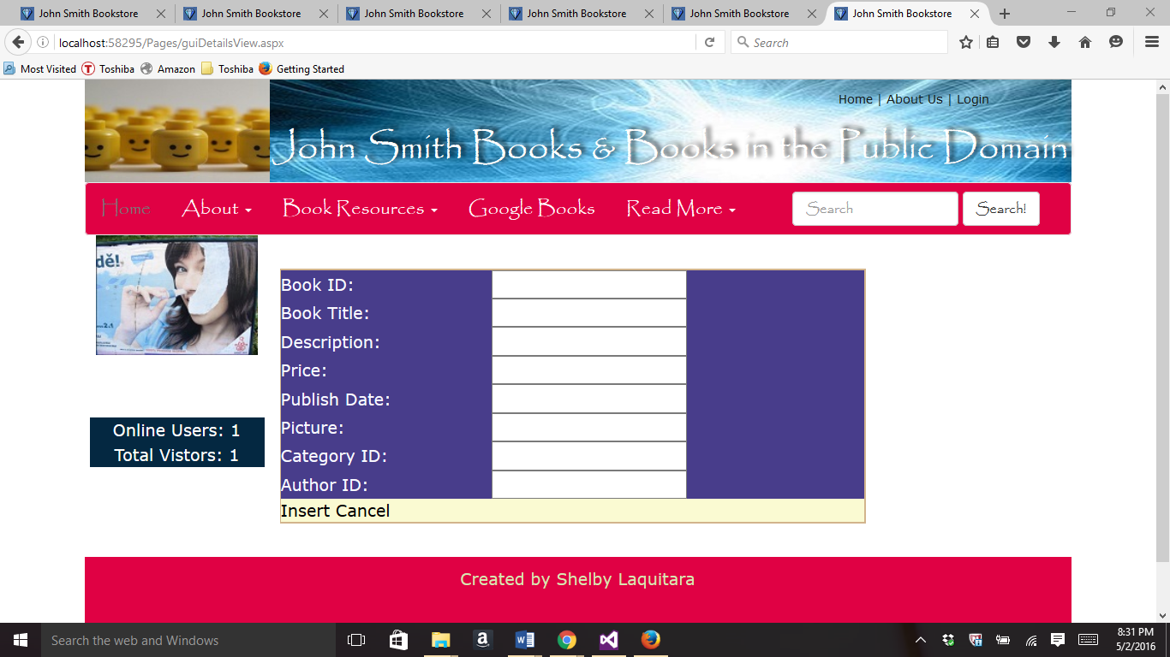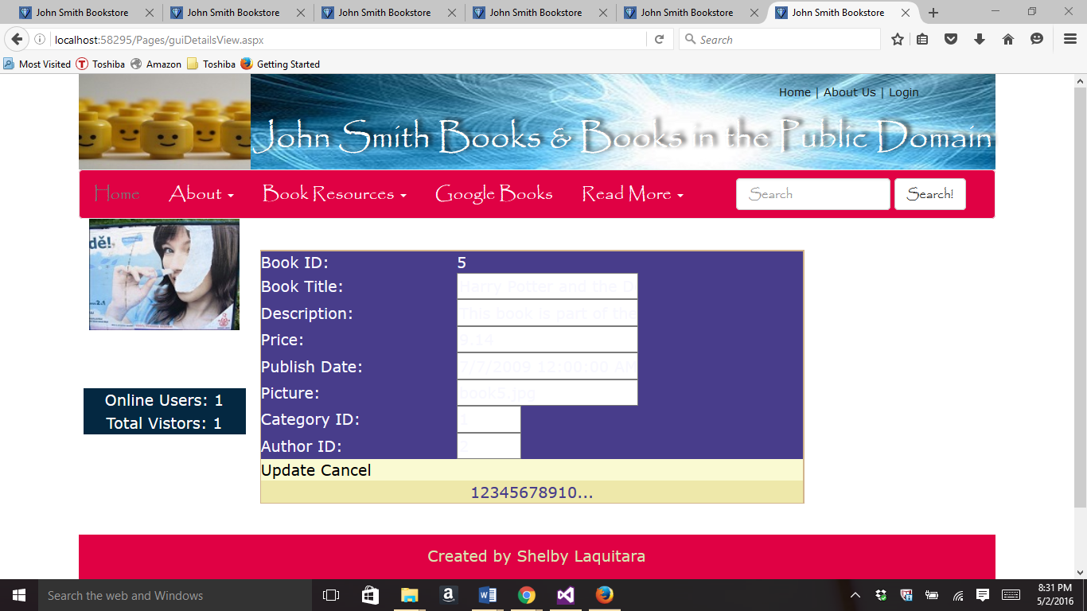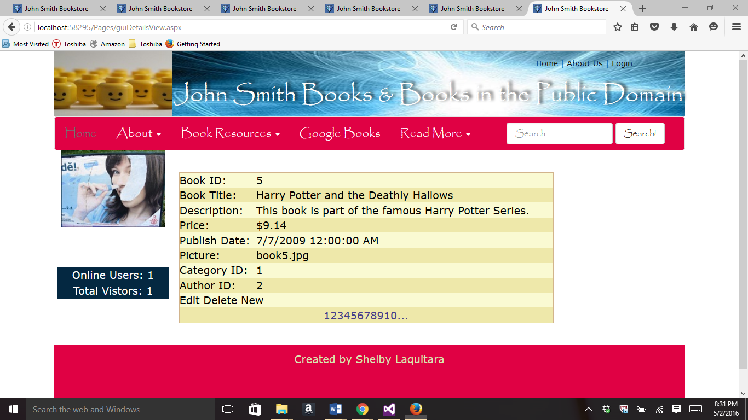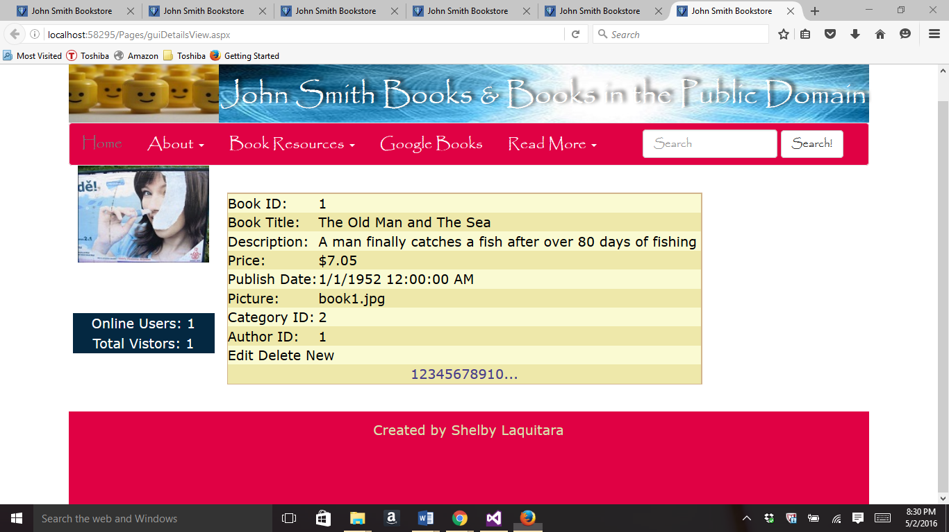

1. Binding a form view control

//guiFormView.aspx code

<%@ Page Title="" Language="C#" MasterPageFile="~/Homework.Master" AutoEventWireup="true" CodeBehind="guiFormView.aspx.cs" Inherits="Project.Pages.guiFormView" %>

<asp:Content ID="Content1" ContentPlaceHolderID="HeadSection" runat="server">

</asp:Content>

<asp:Content ID="Content2" ContentPlaceHolderID="ContentSection" runat="server">

<p>

<asp:SqlDataSource ID="SqlDataSource1" runat="server" ConnectionString="<%$ ConnectionStrings:MyCS %>" DeleteCommand="DELETE FROM [Books] WHERE [bookid] = @bookid" InsertCommand="INSERT INTO [Books] ([bookid], [booktitle], [bookdescription], [price], [pubdate], [picture], [catid], [authorid]) VALUES (@bookid, @booktitle, @bookdescription, @price, @pubdate, @picture, @catid, @authorid)" SelectCommand="SELECT * FROM [Books] ORDER BY [booktitle]" UpdateCommand="UPDATE [Books] SET [booktitle] = @booktitle, [bookdescription] = @bookdescription, [price] = @price, [pubdate] = @pubdate, [picture] = @picture, [catid] = @catid, [authorid] = @authorid WHERE [bookid] = @bookid">

<DeleteParameters>

<asp:Parameter Name="bookid" Type="Int32" />

</DeleteParameters>

<InsertParameters>

<asp:Parameter Name="bookid" Type="Int32" />

<asp:Parameter Name="booktitle" Type="String" />

<asp:Parameter Name="bookdescription" Type="String" />

<asp:Parameter Name="price" Type="Decimal" />

<asp:Parameter Name="pubdate" Type="DateTime" />

<asp:Parameter Name="picture" Type="String" />

<asp:Parameter Name="catid" Type="Int32" />

<asp:Parameter Name="authorid" Type="Int32" />

</InsertParameters>

<UpdateParameters>

<asp:Parameter Name="booktitle" Type="String" />

<asp:Parameter Name="bookdescription" Type="String" />

<asp:Parameter Name="price" Type="Decimal" />

<asp:Parameter Name="pubdate" Type="DateTime" />

<asp:Parameter Name="picture" Type="String" />

<asp:Parameter Name="catid" Type="Int32" />

<asp:Parameter Name="authorid" Type="Int32" />

<asp:Parameter Name="bookid" Type="Int32" />

</UpdateParameters>

</asp:SqlDataSource>

<br />

<asp:FormView ID="FormView1" runat="server" AllowPaging="True" BackColor="LightGoldenrodYellow" BorderColor="Tan" BorderWidth="1px" CellPadding="2" DataKeyNames="bookid" DataSourceID="SqlDataSource1" ForeColor="Black" Width="358px">

<EditItemTemplate>

bookid:

<asp:Label ID="bookidLabel1" runat="server" Text='<%# Eval("bookid") %>' />

<br />

booktitle:

<asp:TextBox ID="booktitleTextBox" runat="server" Text='<%# Bind("booktitle") %>' />

<br />

bookdescription:

<asp:TextBox ID="bookdescriptionTextBox" runat="server" Text='<%# Bind("bookdescription") %>' />

<br />

price:

<asp:TextBox ID="priceTextBox" runat="server" Text='<%# Bind("price") %>' />

<br />

pubdate:

<asp:TextBox ID="pubdateTextBox" runat="server" Text='<%# Bind("pubdate") %>' />

<br />

picture:

<asp:TextBox ID="pictureTextBox" runat="server" Text='<%# Bind("picture") %>' />

<br />

catid:

<asp:TextBox ID="catidTextBox" runat="server" Text='<%# Bind("catid") %>' />

<br />

authorid:

<asp:TextBox ID="authoridTextBox" runat="server" Text='<%# Bind("authorid") %>' />

<br />

<asp:LinkButton ID="UpdateButton" runat="server" CausesValidation="True" CommandName="Update" Text="Update" />

&nbsp;<asp:LinkButton ID="UpdateCancelButton" runat="server" CausesValidation="False" CommandName="Cancel" Text="Cancel" />

</EditItemTemplate>

<EditRowStyle BackColor="DarkSlateBlue" ForeColor="GhostWhite" />

<FooterStyle BackColor="Tan" />

<HeaderStyle BackColor="Tan" Font-Bold="True" />

<InsertItemTemplate>

bookid:

<asp:TextBox ID="bookidTextBox" runat="server" Text='<%# Bind("bookid") %>' />

<br />

booktitle:

<asp:TextBox ID="booktitleTextBox" runat="server" Text='<%# Bind("booktitle") %>' />

<br />

bookdescription:

<asp:TextBox ID="bookdescriptionTextBox" runat="server" Text='<%# Bind("bookdescription") %>' />

<br />

price:

<asp:TextBox ID="priceTextBox" runat="server" Text='<%# Bind("price") %>' />

<br />

pubdate:

<asp:TextBox ID="pubdateTextBox" runat="server" Text='<%# Bind("pubdate") %>' />

<br />

picture:

<asp:TextBox ID="pictureTextBox" runat="server" Text='<%# Bind("picture") %>' />

<br />

catid:

<asp:TextBox ID="catidTextBox" runat="server" Text='<%# Bind("catid") %>' />

<br />

authorid:

<asp:TextBox ID="authoridTextBox" runat="server" Text='<%# Bind("authorid") %>' />

<br />

<asp:LinkButton ID="InsertButton" runat="server" CausesValidation="True" CommandName="Insert" Text="Insert" />

&nbsp;<asp:LinkButton ID="InsertCancelButton" runat="server" CausesValidation="False" CommandName="Cancel" Text="Cancel" />

</InsertItemTemplate>

<ItemTemplate>

bookid:

<asp:Label ID="bookidLabel" runat="server" Text='<%# Eval("bookid") %>' />

<br />

booktitle:

<asp:Label ID="booktitleLabel" runat="server" Text='<%# Bind("booktitle") %>' />

<br />

bookdescription:

<asp:Label ID="bookdescriptionLabel" runat="server" Text='<%# Bind("bookdescription") %>' />

<br />

price:

<asp:Label ID="priceLabel" runat="server" Text='<%# Bind("price") %>' />

<br />

pubdate:

<asp:Label ID="pubdateLabel" runat="server" Text='<%# Bind("pubdate") %>' />

<br />

picture:

<asp:Label ID="pictureLabel" runat="server" Text='<%# Bind("picture") %>' />

<br />

catid:

<asp:Label ID="catidLabel" runat="server" Text='<%# Bind("catid") %>' />

<br />

authorid:

<asp:Label ID="authoridLabel" runat="server" Text='<%# Bind("authorid") %>' />

<br />

<asp:LinkButton ID="EditButton" runat="server" CausesValidation="False" CommandName="Edit" Text="Edit" />

&nbsp;<asp:LinkButton ID="DeleteButton" runat="server" CausesValidation="False" CommandName="Delete" Text="Delete" />

&nbsp;<asp:LinkButton ID="NewButton" runat="server" CausesValidation="False" CommandName="New" Text="New" />

</ItemTemplate>

<PagerStyle BackColor="PaleGoldenrod" ForeColor="DarkSlateBlue" HorizontalAlign="Center" />

</asp:FormView>

</p>

<p>

</p>

<p>

</p>

<p>

</p>

<p>

</p>

<p>

</p>

</asp:Content>

//guiFormView.aspx in browser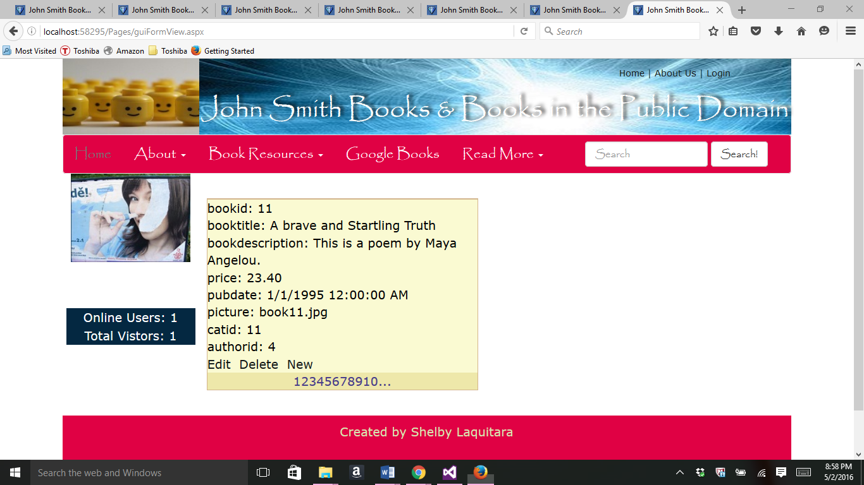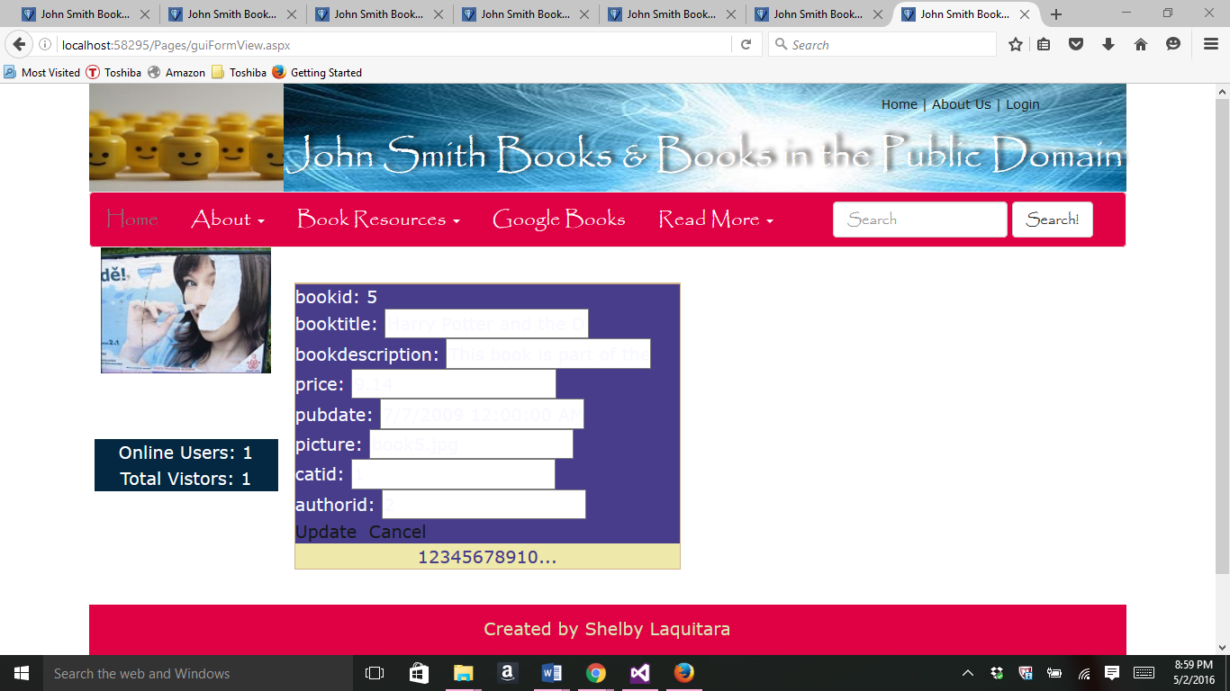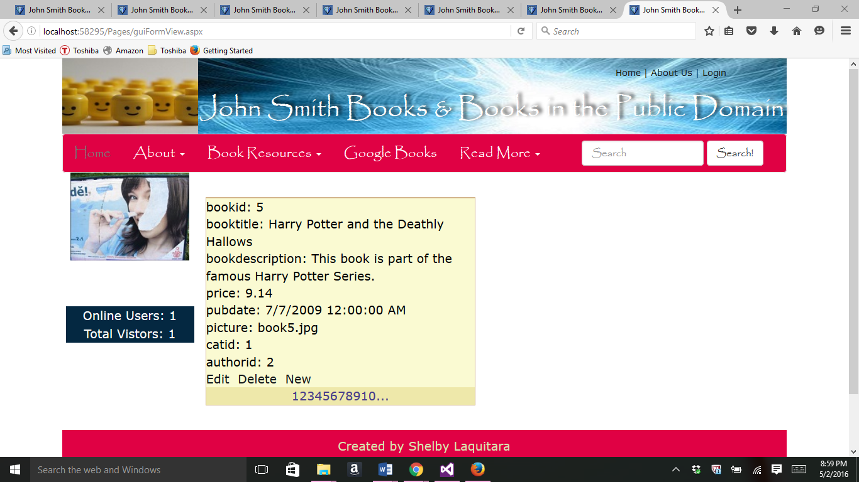

Part 2-

//FormatGridView.aspx code

<%@ Page Title="" Language="C#" MasterPageFile="~/Homework.Master" AutoEventWireup="true" CodeBehind="guiFormatGridView.aspx.cs" Inherits="Project.Pages.guiFormatGridView" %>

<asp:Content ID="Content1" ContentPlaceHolderID="HeadSection" runat="server">

</asp:Content>

<asp:Content ID="Content2" ContentPlaceHolderID="ContentSection" runat="server">

<p>

<br />

<asp:SqlDataSource ID="SqlDataSource1" runat="server"

ConnectionString="<%$ ConnectionStrings:MyCS %>"

SelectCommand="SELECT [lastname], [authorid] FROM [Authors] ORDER BY [lastname]">

</asp:SqlDataSource>

</p>

<p>

<asp:DropDownList ID="DropDownList1" runat="server"

AutoPostBack="True" DataSourceID="SqlDataSource1"

DataTextField="lastname" DataValueField="authorid">

</asp:DropDownList>

</p>

<p>

&nbsp;</p>

<p>

<asp:SqlDataSource ID="SqlDataSource2" runat="server"

ConnectionString="<%$ ConnectionStrings:MyCS %>"

SelectCommand="SELECT * FROM [Books] WHERE ([authorid] = @authorid) ORDER BY [booktitle]" DeleteCommand="DELETE FROM [Books] WHERE [bookid] = @bookid" InsertCommand="INSERT INTO [Books] ([bookid], [booktitle], [bookdescription], [price], [pubdate], [picture], [catid], [authorid]) VALUES (@bookid, @booktitle, @bookdescription, @price, @pubdate, @picture, @catid, @authorid)" UpdateCommand="UPDATE [Books] SET [booktitle] = @booktitle, [bookdescription] = @bookdescription, [price] = @price, [pubdate] = @pubdate, [picture] = @picture, [catid] = @catid, [authorid] = @authorid WHERE [bookid] = @bookid">

<DeleteParameters>

<asp:Parameter Name="bookid" Type="Int32" />

</DeleteParameters>

<InsertParameters>

<asp:Parameter Name="bookid" Type="Int32" />

<asp:Parameter Name="booktitle" Type="String" />

<asp:Parameter Name="bookdescription" Type="String" />

<asp:Parameter Name="price" Type="Decimal" />

<asp:Parameter Name="pubdate" Type="DateTime" />

<asp:Parameter Name="picture" Type="String" />

<asp:Parameter Name="catid" Type="Int32" />

<asp:Parameter Name="authorid" Type="Int32" />

</InsertParameters>

<SelectParameters>

<asp:ControlParameter ControlID="DropDownList1"

Name="authorid" PropertyName="SelectedValue" Type="Int32" />

</SelectParameters>

<UpdateParameters>

<asp:Parameter Name="booktitle" Type="String" />

<asp:Parameter Name="bookdescription" Type="String" />

<asp:Parameter Name="price" Type="Decimal" />

<asp:Parameter Name="pubdate" Type="DateTime" />

<asp:Parameter Name="picture" Type="String" />

<asp:Parameter Name="catid" Type="Int32" />

<asp:Parameter Name="authorid" Type="Int32" />

<asp:Parameter Name="bookid" Type="Int32" />

</UpdateParameters>

</asp:SqlDataSource>

</p>

<p>

<asp:GridView ID="GridView1" runat="server" AllowPaging="True"

AllowSorting="True" AutoGenerateColumns="False"

DataKeyNames="bookid" DataSourceID="SqlDataSource2" SkinID="testGridView">

<Columns>

<asp:CommandField ButtonType="Button" ShowDeleteButton="True" ShowEditButton="True" />

<asp:BoundField DataField="bookid" HeaderText="ID" ReadOnly="True"

SortExpression="bookid" >

<HeaderStyle HorizontalAlign="Center" />

<ItemStyle HorizontalAlign="Center" />

</asp:BoundField>

<asp:BoundField DataField="booktitle" HeaderText="Book Title"

SortExpression="booktitle" >

<HeaderStyle HorizontalAlign="Center" />

</asp:BoundField>

<%--<asp:BoundField DataField="bookdescription" HeaderText="bookdescription"

SortExpression="bookdescription" />--%>

<asp:BoundField DataField="price" HeaderText="Price"

SortExpression="price" DataFormatString="{0:c}" >

<HeaderStyle HorizontalAlign="Center" />

<ItemStyle HorizontalAlign="Center" />

</asp:BoundField>

<asp:BoundField DataField="pubdate" HeaderText="Publish Date"

SortExpression="pubdate" DataFormatString="{0:d}">

<HeaderStyle HorizontalAlign="Center" />

<ItemStyle HorizontalAlign="Center" />

</asp:BoundField>

<asp:BoundField DataField="picture" HeaderText="Picture"

SortExpression="picture" >

<HeaderStyle HorizontalAlign="Center" />

<ItemStyle HorizontalAlign="Center" />

</asp:BoundField>

<%--<asp:BoundField DataField="catid" HeaderText="catid"

SortExpression="catid" />

<asp:BoundField DataField="authorid" HeaderText="authorid"

SortExpression="authorid" />--%>

</Columns>

</asp:GridView>

</p>

<p>

</p>

<p>

</p>

<p>

</p>

</asp:Content>

//GridView.Skin code

<asp:GridView runat="server" AllowPaging="True"

AllowSorting="True" AutoGenerateColumns="False"

CellPadding="4" Font-Size="Small"

ForeColor="Black" GridLines="None" SkinID="testGridView">

<AlternatingRowStyle BackColor="PaleGoldenrod" />

<FooterStyle BackColor="Tan" />

<HeaderStyle BackColor="Tan" Font-Bold="True" />

<PagerSettings Mode="NextPrevious" />

<PagerStyle BackColor="PaleGoldenrod" ForeColor="DarkSlateBlue"

HorizontalAlign="Center" />

<SelectedRowStyle BackColor="DarkSlateBlue" ForeColor="GhostWhite" />

<SortedAscendingCellStyle BackColor="#FAFAE7" />

<SortedAscendingHeaderStyle BackColor="#DAC09E" />

<SortedDescendingCellStyle BackColor="#E1DB9C" />

<SortedDescendingHeaderStyle BackColor="#C2A47B" />

</asp:GridView>

//FormatGridView.aspx code in Browser